GROUP 1 MVP TRAINING MANUAL

Step by Step guide to get you ready for using the MVP.

Cumulated Efforts by:

Rick Kalouche

Zoe Fong

Michelle Wang

Christopher Rigor

Thomas Yap

Contents

***Data Cleansing*** 2

*Process of cleansing and preparing data* 2

*Cleansing and preparing a data set* 2

*Integrating separate data sets* 5

***Windows Installation Guide for Anaconda*** 12

***Jupyter Access Instructions*** 19

***Packages*** 22

***Dataset and Dataframe Manipulation*** 22

*Data Cleaning and Manipulation* 22

*Aggregating Data* 23

***Documentation*** 24

*Legend* 24

*Packages* 24

***Dataset and Dataframe Manipulation*** 25

***Data Cleaning and Manipulation*** 25

***Aggregating Data*** 26

***Data Visualisation / Exploration*** 26

***Modelling*** 28

***Creating Model Dataframe*** 28

***KNN*** 30

***ARIMA*** 30

***DTR*** 32

***Logistic Regression*** 33

***Prediction*** 34

***Choosing Parameters*** 34

# ***Data Cleansing***

The cleansing of the data sets before they are imported into Jupyter is vital to ensure that the program runs smoothly free of errors in order to give accurate results. This is especially important when dealing with large amounts of data to be able to take advantage of running effective analysis. This process will involve identifying inconsistencies, mistakes and errors in the data and fixing these issues, as well as reformatting and cutting. The only tool required for data cleaning is Microsoft Excel.

The main outcome of this process is to create high quality data. Meeting the goal of quality data ensures that the data being used is thoroughly cleansed. Quality data is defined by five characteristics which are:

* Accuracy - The information that the data contains is correct.
* Reliability - The data doesn’t contract other pieces of data in other data sets.
* Completeness - All elements of the data are readily available.
* Relevance - The data collected is suitable and appropriate for its intended purpose.
* Timeliness - The data is up to date and accurate to a reasonable time period.

## *Process of cleansing and preparing data*

This section aims to explain how to cleanse, prepare and integrate raw data sets using Excel to ensure it’s ready for analysis through Jupyter. Additional instructions will be provided for users who want to combine and integrate separate data sets from steps X to Y.

## *Cleansing and preparing a data set*

This section shows how to cleanse and prepare a data set for analysis step by step.

Step 1: Data inspection

Go through the data set and remove duplicated or irrelevant columns. Be aware of the primary keys, they are the unique identifier/value in the data set. Do not delete the primary key.

In the example below, the orange boxes represent the column that needs to be removed.

* “SHIPYEAR” and “SHIPMONTH” are duplicated and getting deleted as the year and month are already mentioned in “SHIPDATE”.
* “C_STATE” is irrelevant and getting removed as “C_ZIP” is provided.
* “DESCR”, which is the description of the item is irrelevant and getting removed.

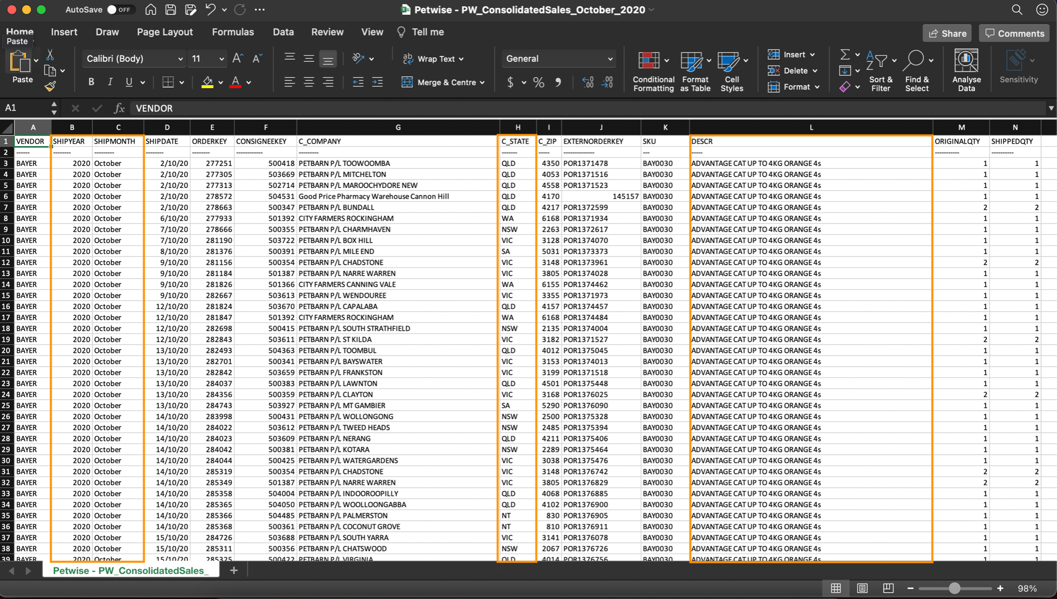

In order to delete, users are to select the column using the cursor, right click, and then select “delete”, as shown on the screenshot below.

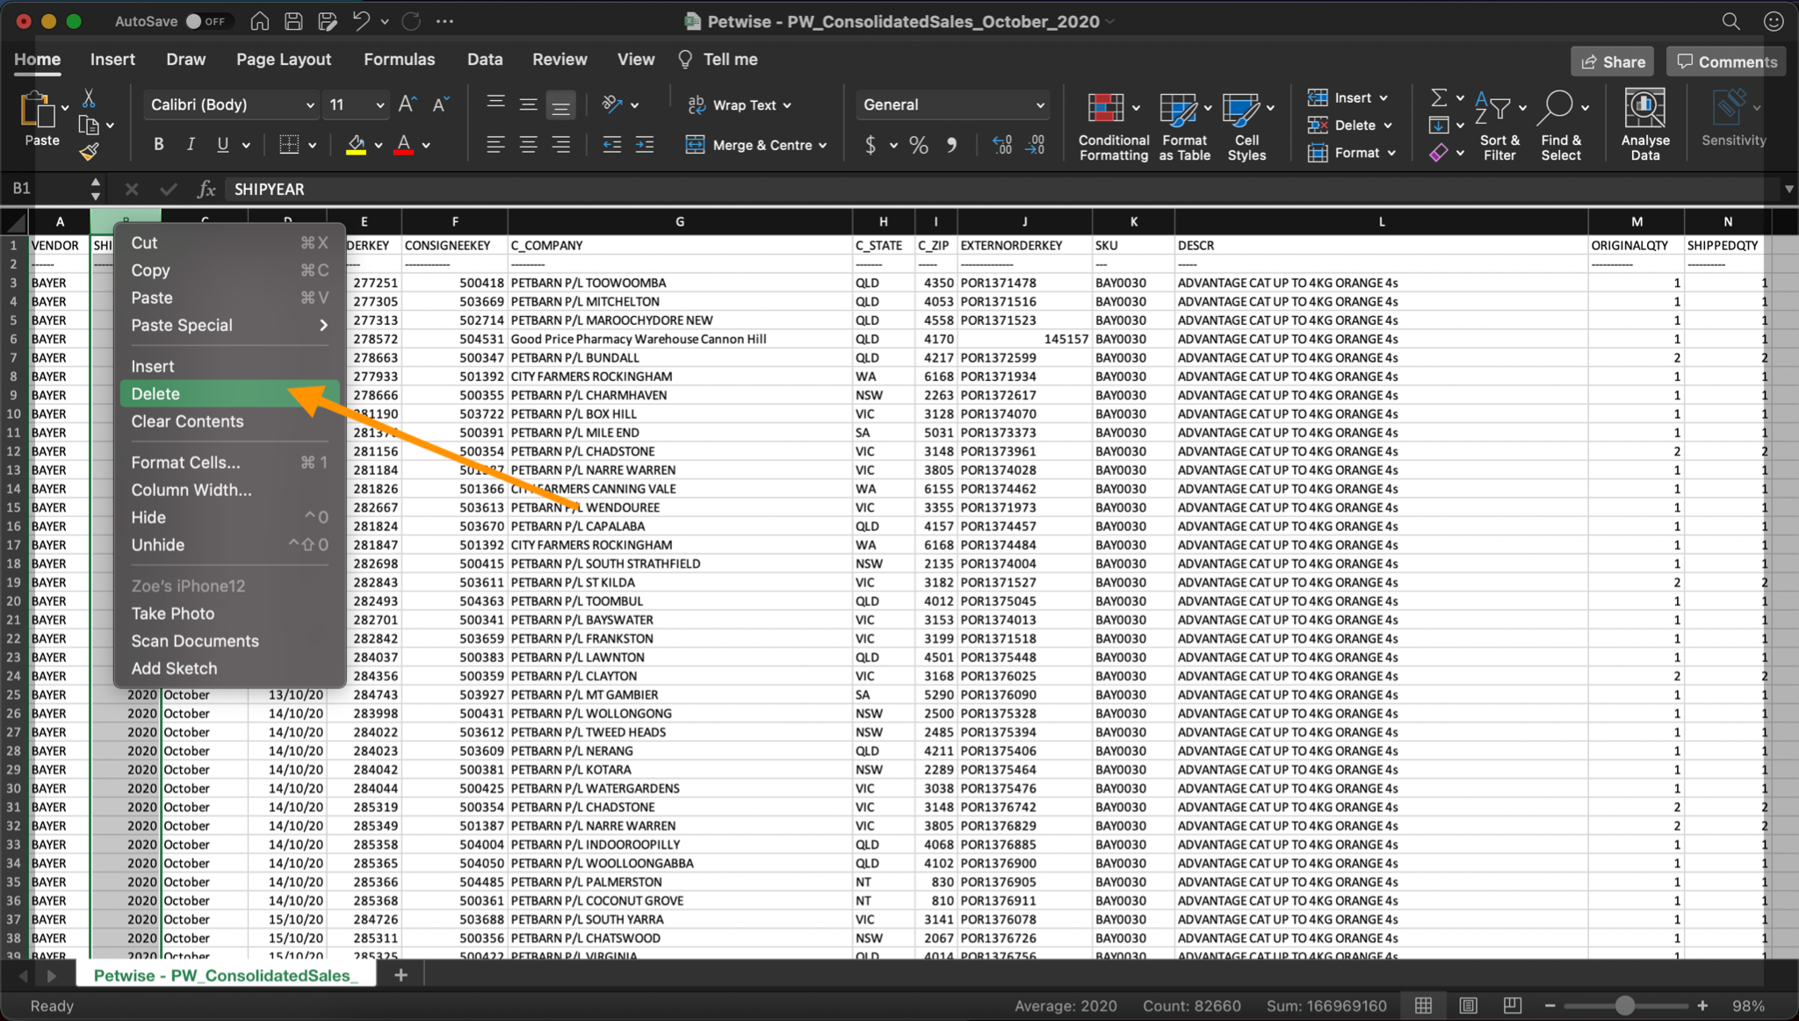

Step 2: Structural errors correction

After step 1, go through the data set again to find any typos or syntax error. They could be mis-spelling words, capitalisation, etc. The red box in the following example represents the errors. Fix the error if they are minor. If they cannot be fixed, one can move to the next step.

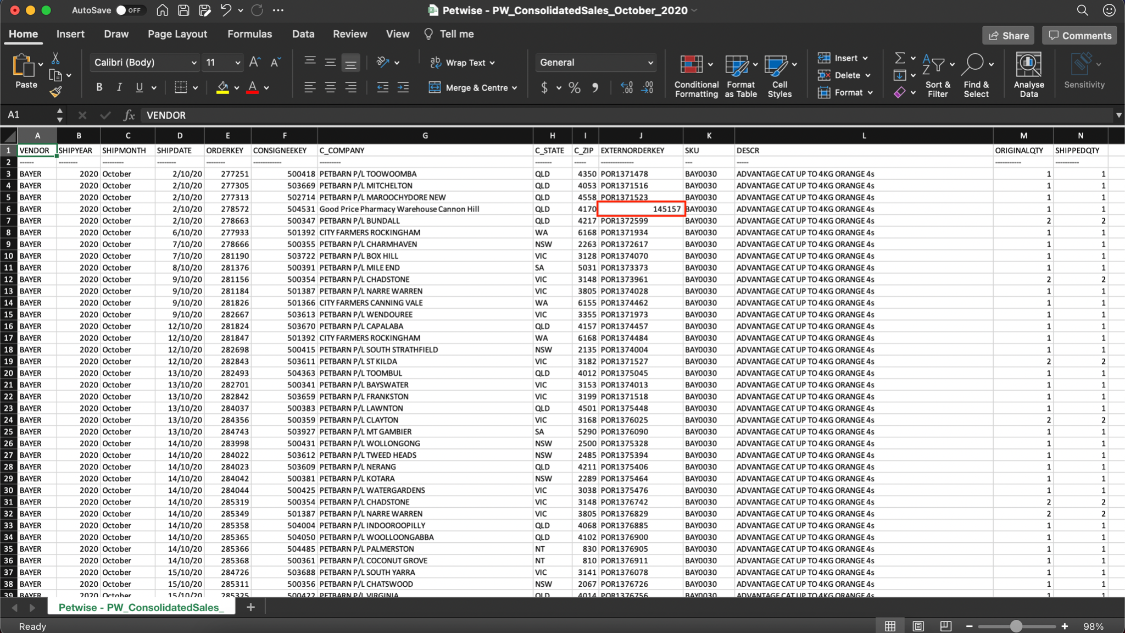

Step 3: Take notes of the missing data

After step 2, if there is missing data, the whole column should be dropped or import data based on observations on the rest of the data. This may involve making up the missing data.

In the following example, two data sets are shown, the one on the left is data from October, the right is from November. Two data sets are meant to be in the same format, however, a column is missing in the October one. Users will have to decide whether they want to drop the corresponding column in other data sets or make the data up according to the data. In this case, it is better to drop the column in the November set.

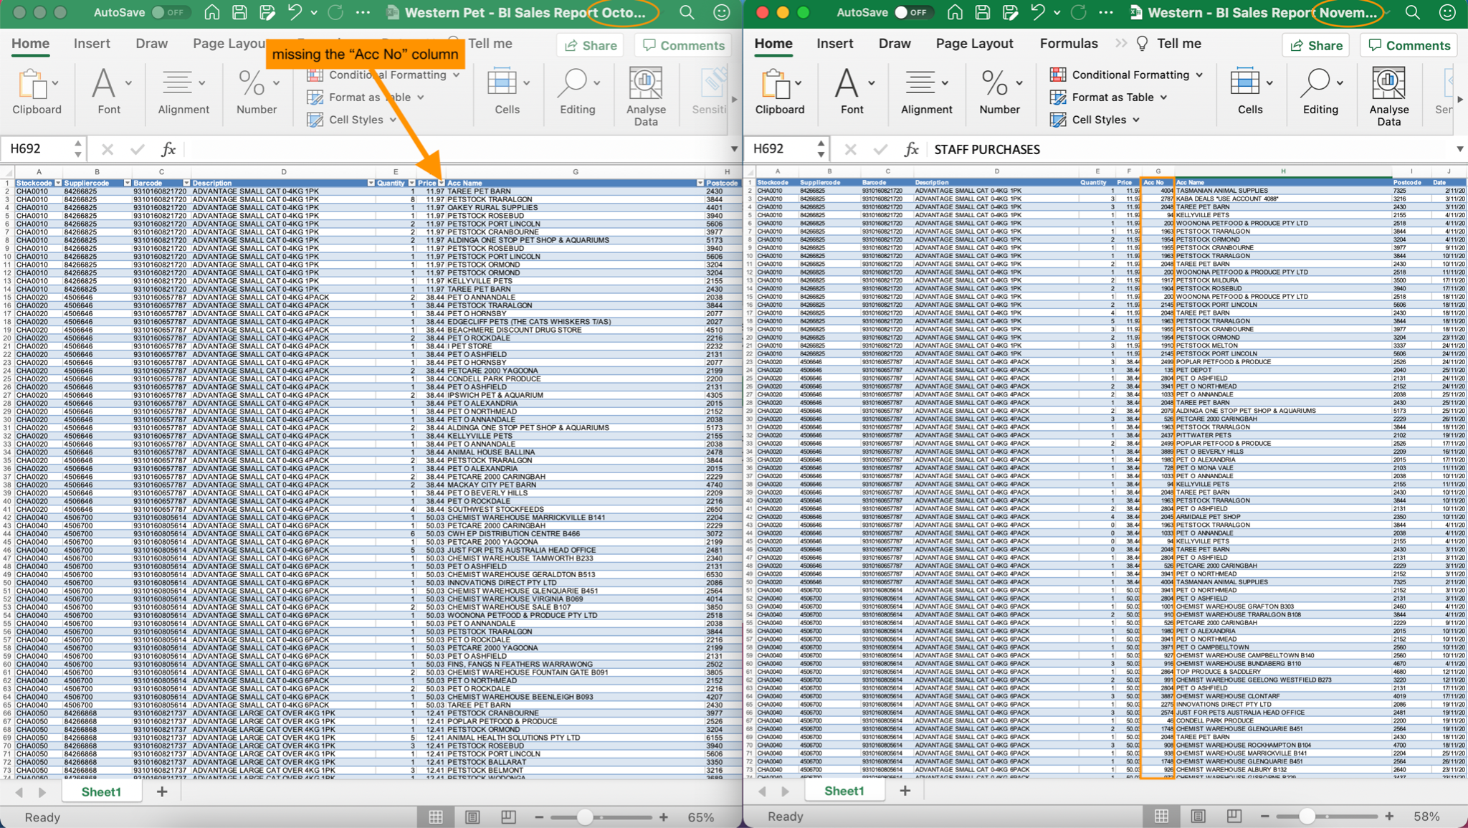

## *Integrating separate data sets*

The following steps are for users who want to combine separate data sets into one. For example, three different data sets containing the sales of a product are separated into January, February and March sales data sets. The user may want to combine these data sets for analysis. The following steps will explain how to integrate these months into one data set.

Step 4: Combining data sets

First, ensure the data sets have the same columns and data types before combining. In the screenshots below, Western sales reports for October and November have the same exact columns and data types. Therefore they are ready for integration.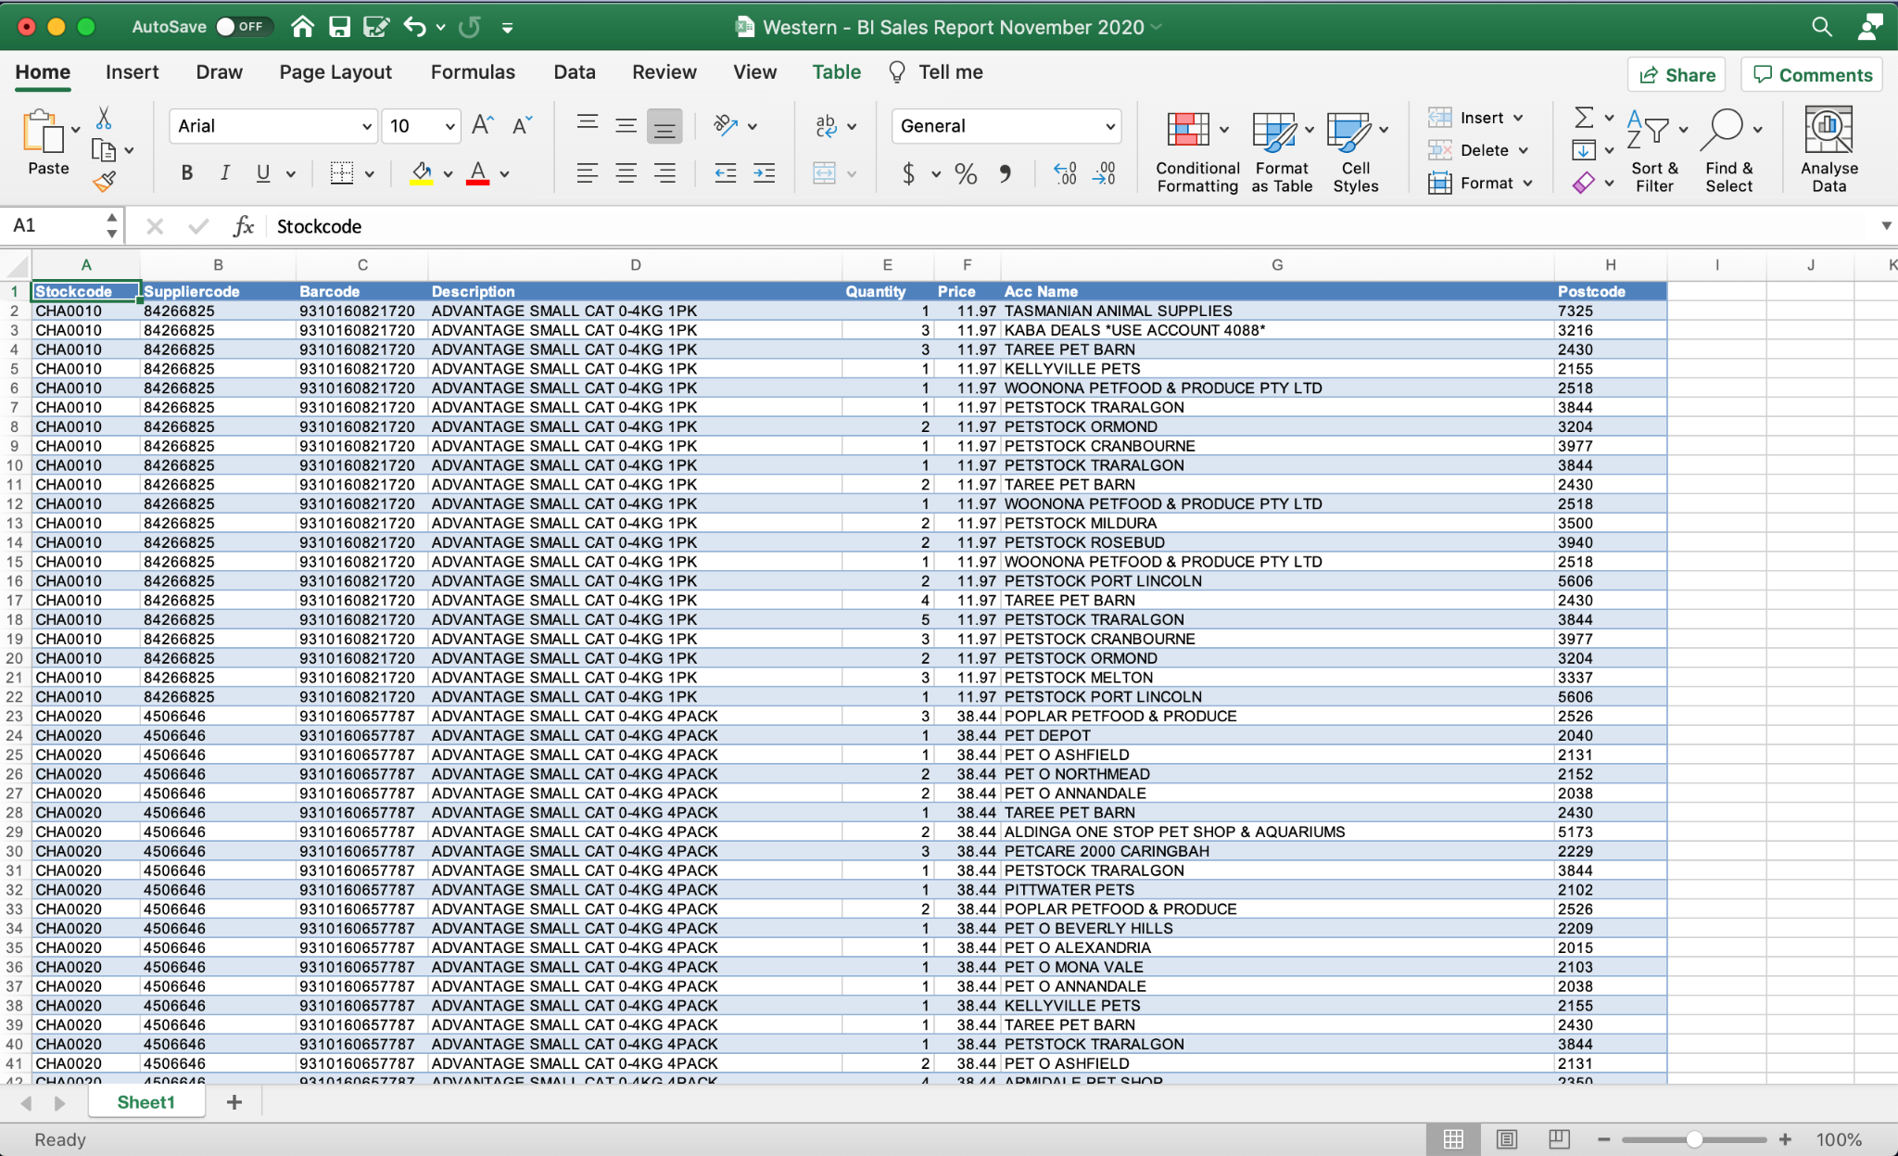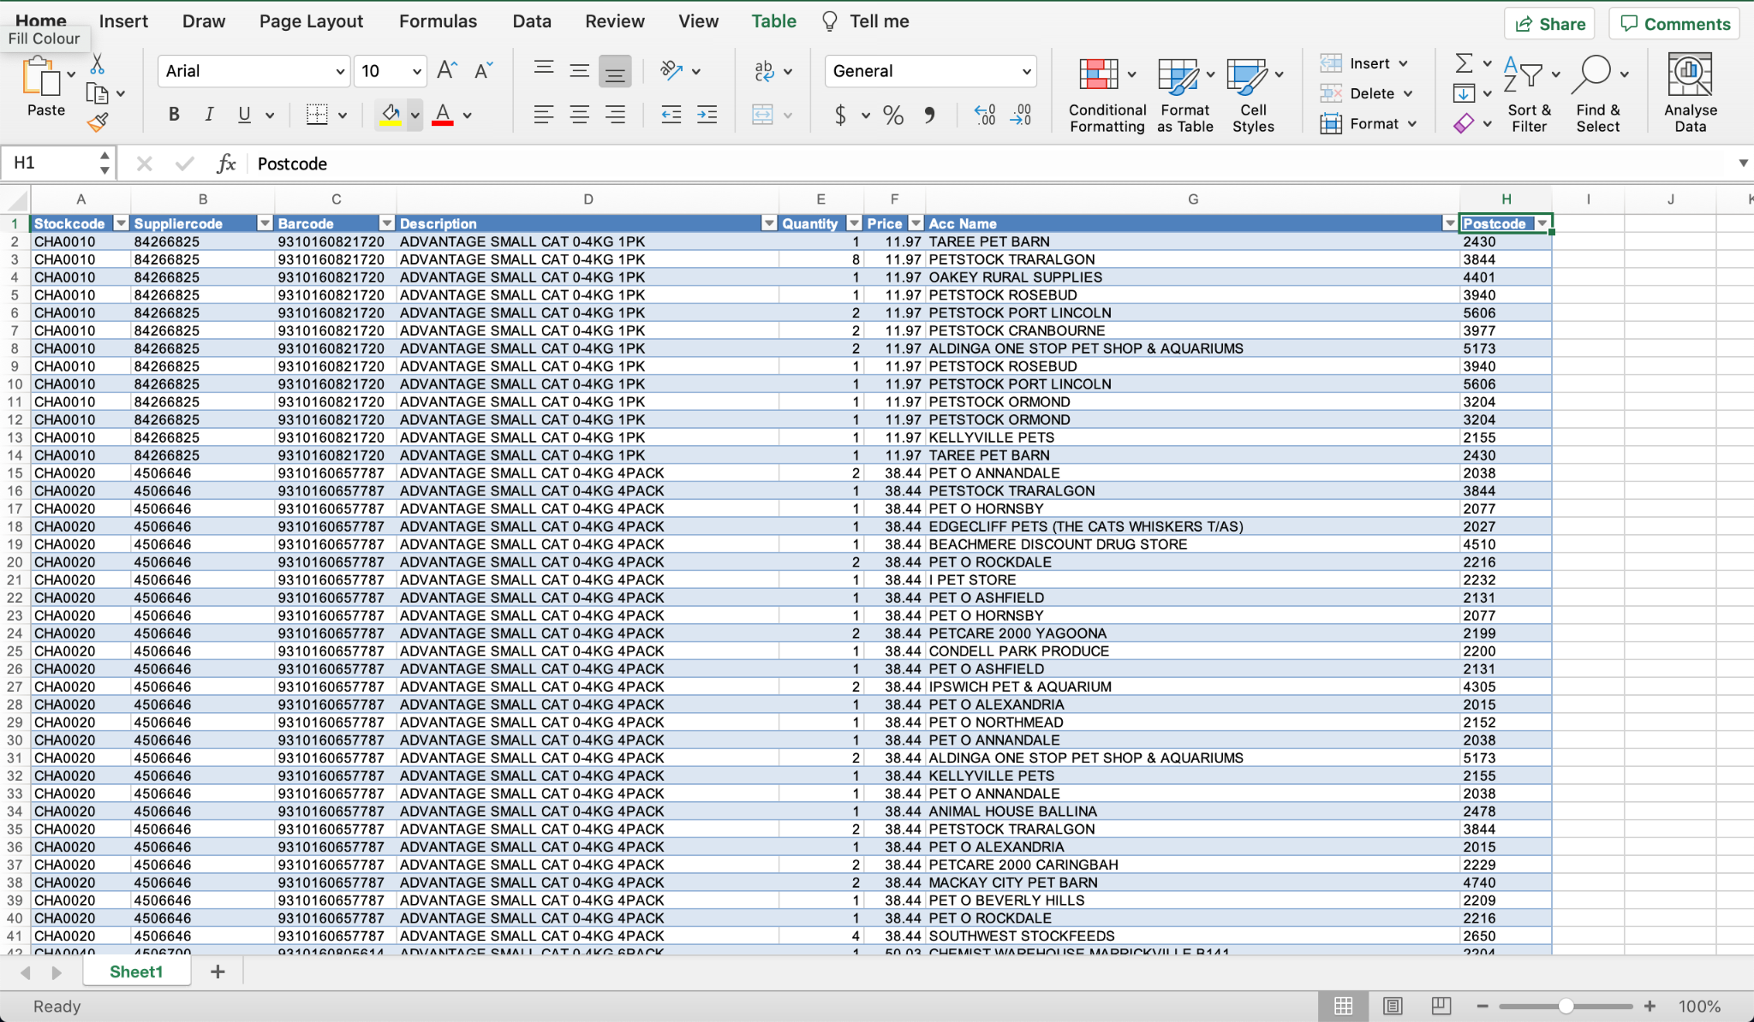

Step 5: Left click the A1 cell of one of the data sets and press CTRL+A (CMD+A for mac) to select the entire table, then press right click and select Copy to copy the table.

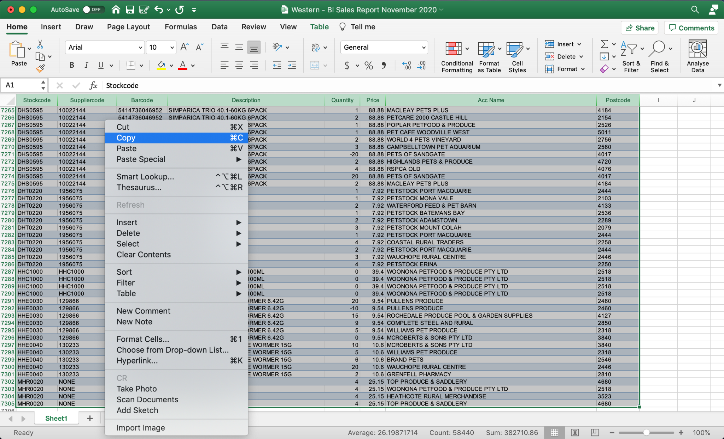

Step 6: Create a new spreadsheet. Then right click the A1 cell, hover on paste special, then select Keep Source Column Widths to put the table in the spreadsheet. 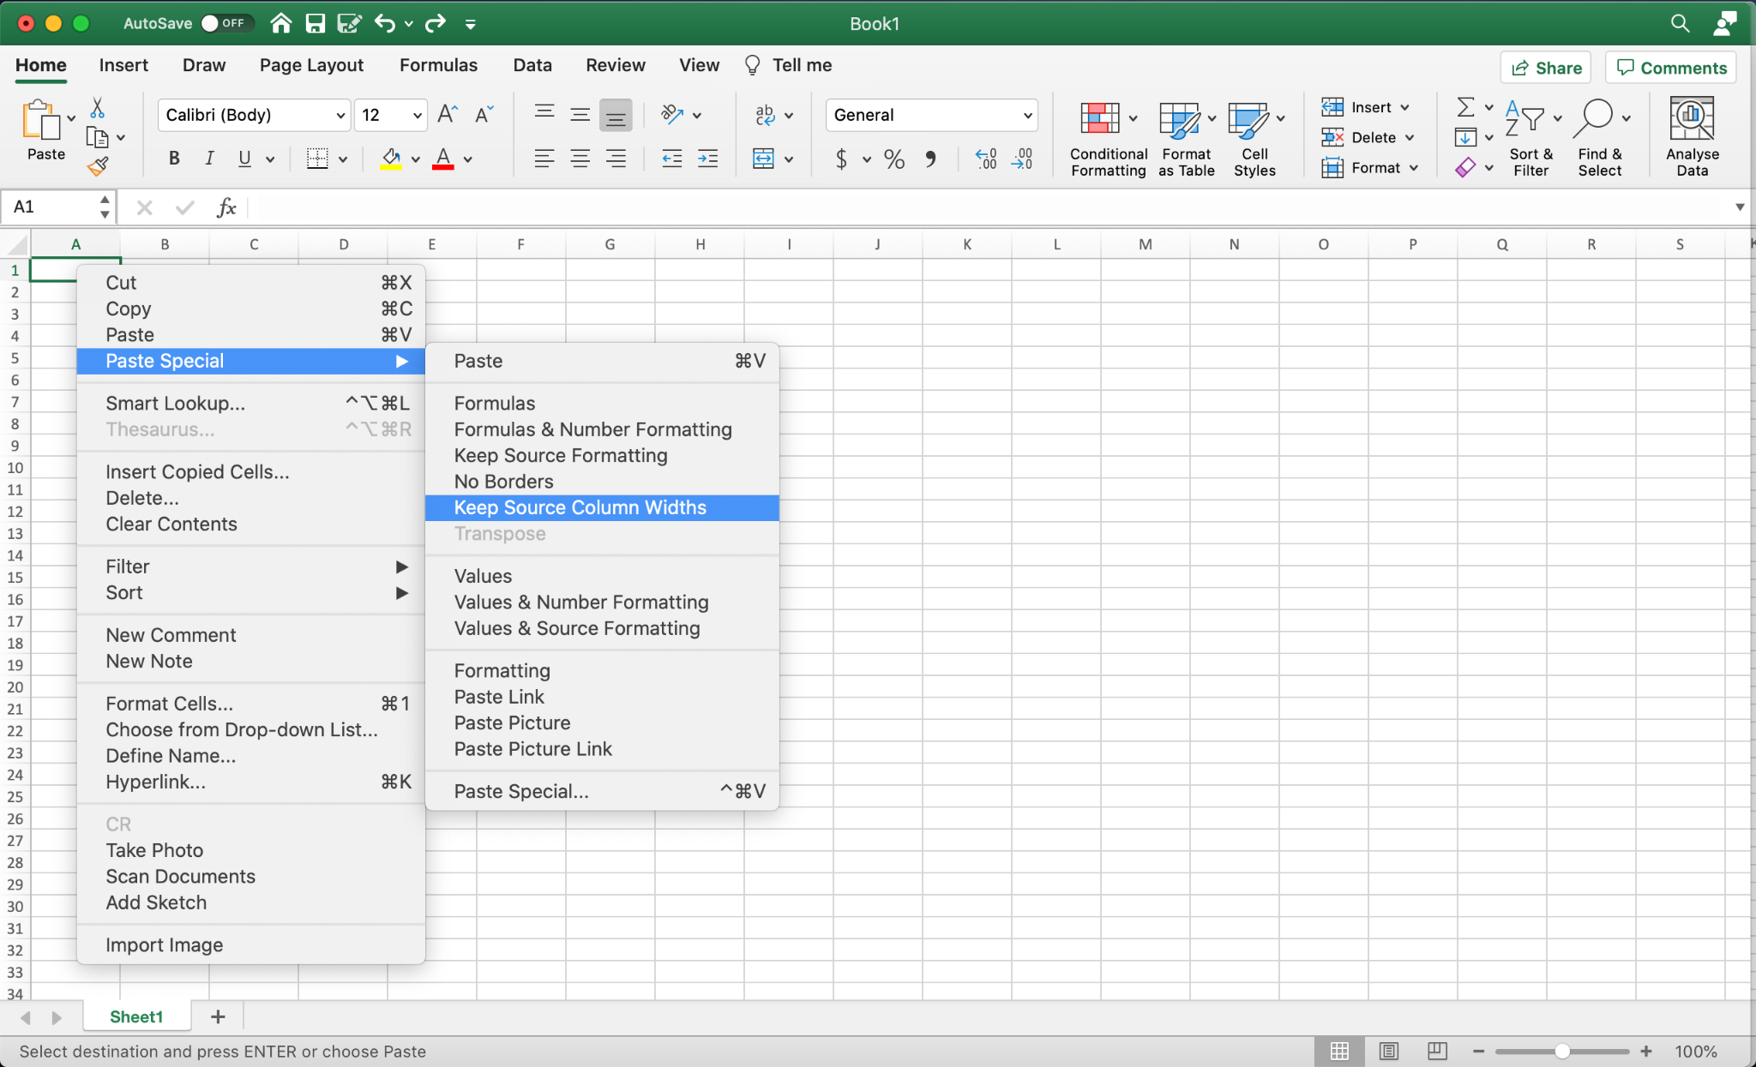

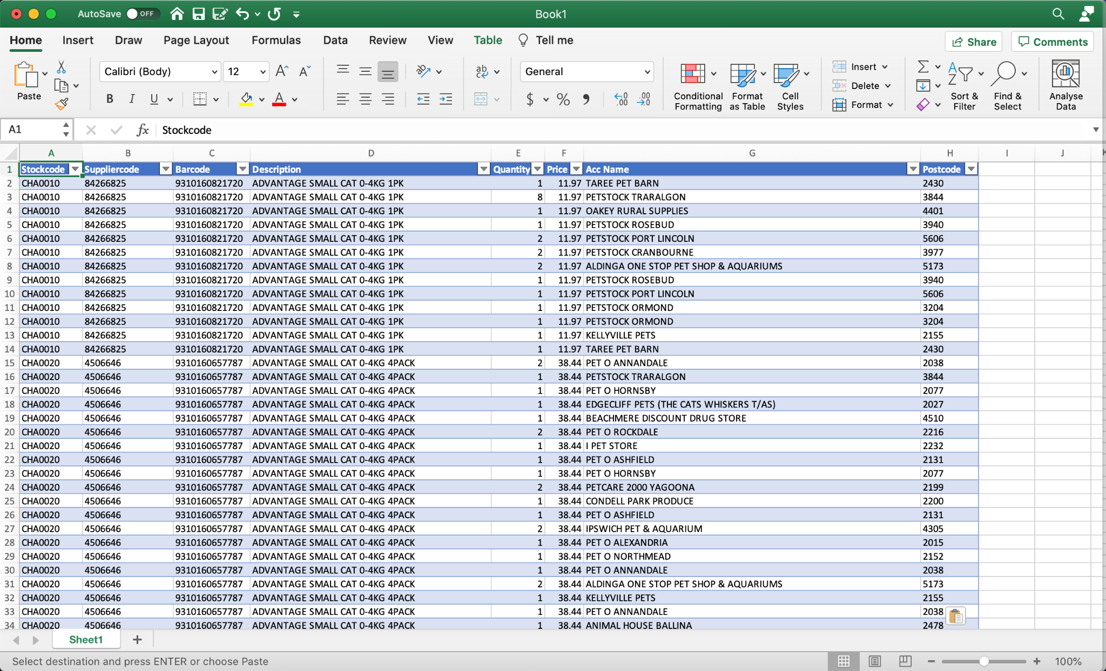

Step 7: On the other data set(s), left click the A2 cell of one of the data sets and press CTRL+A (CMD+A for mac) to select the entire table without the column headings, then right click and select Copy to copy the table.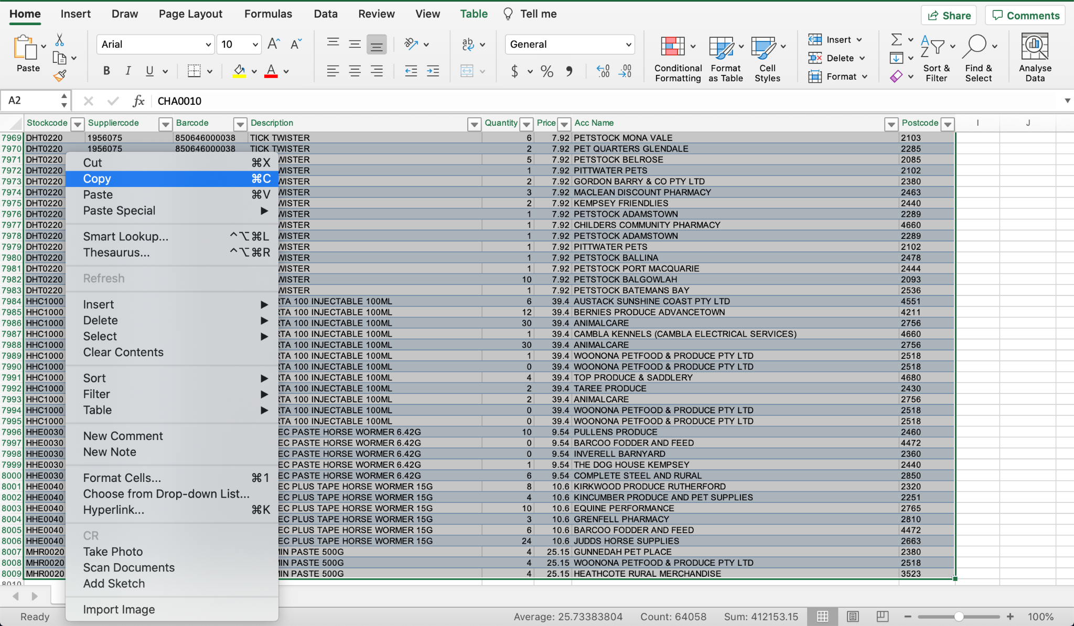

Step 8: On the new spreadsheet, press CTRL+ any arrow key to navigate to the end of the spreadsheet. Then right click the cell in column A under the data and press paste.

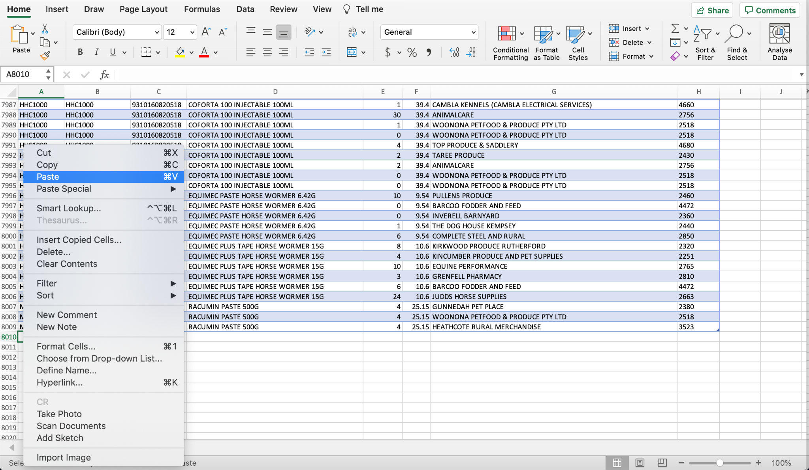

Repeat steps 7 and 8 if more than two data sets are to be combined.

# ***Windows Installation Guide for Anaconda***

In order to install Jupyter, another base line program called ‘Anaconda’. First, ensure that you have the following minimum system requirements needed for Anaconda. The requirements are as follows:

* Operating System: Windows 8 or newer
* System Architecture: Windows 64bit x86 OR 32bit x86
* Minimum 5 GB Disk Space

After verifying system requirements, head to anaconda.com/products/individual on a search engine. After visiting the website, scroll down to the bottom, and click to download either 64bit or 32bit installer, based on your system specifications.

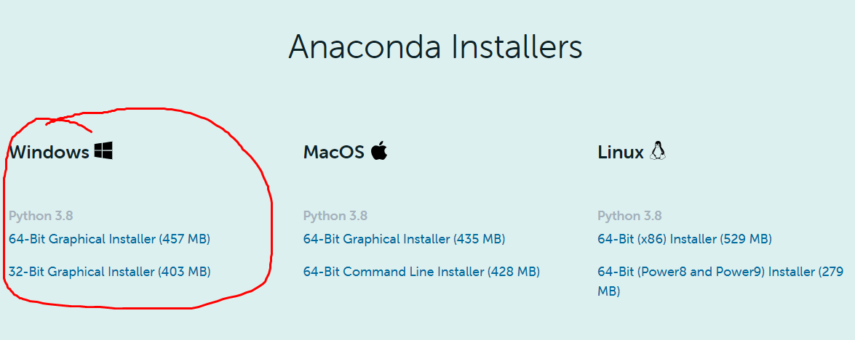

After clicking the specified installer, the program will continue to download at the bottom tab of the search engine, in this instance the user has google chrome. Continue to Wait the specified time, and then click on the Anaconda.exe file.

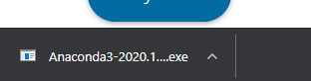

You will then see this screen.

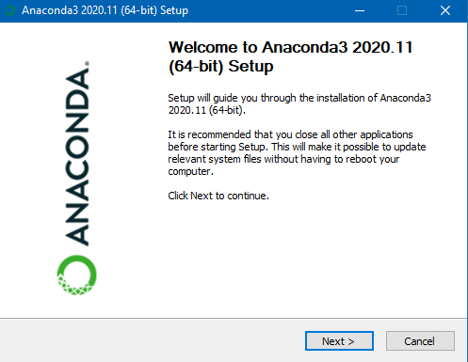

Click “Next >” which will then take you to a license agreement. Read the agreement and accept the terms and conditions by clicking “I Agree”

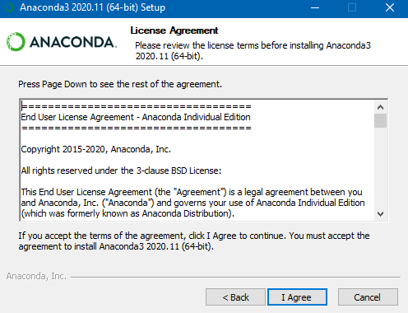

The user will be then greeted by the following screen. If the PC/Computer in use only has one user, click the “Just Me” option. Otherwise, Click the “All Users” Option.

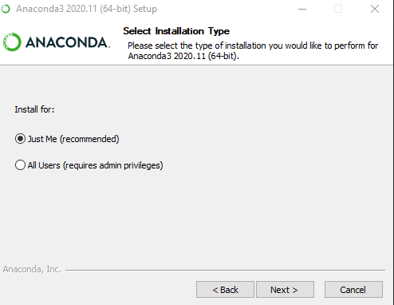

If the “All Users” option is selected, the following will appear:

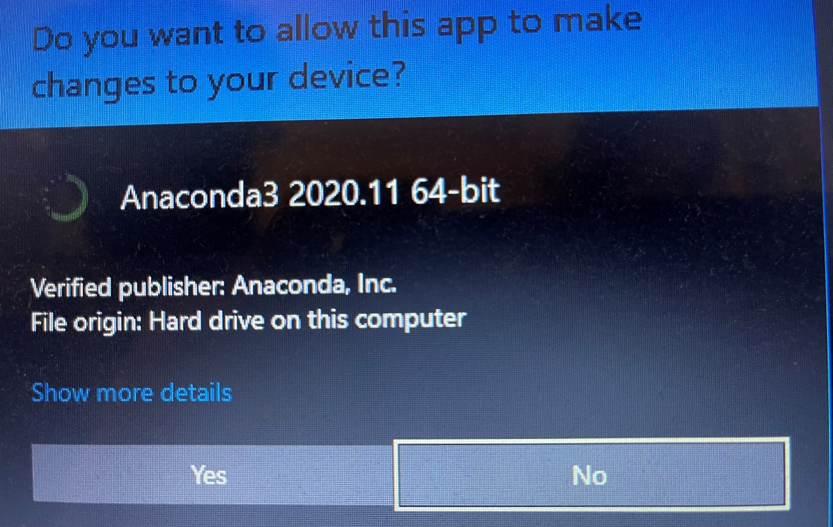

Click “Yes” and continue with the instructions below.

After clicking which type of installation the user would like, hit “Next >”. The following screen will appear:

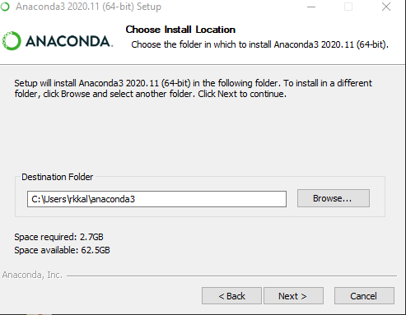

First, verify that you have the required space for the program. This space will change depending on the device you are on. Secondly, Check the destination folder to determine if the auto selected file location is plausible, or Click “Browse…” to select another file location. The following screen will appear when clicking “Browse…”

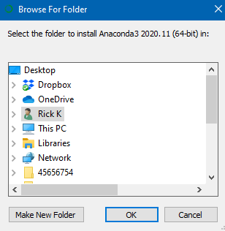

The user can then decide where Anaconda files will be stored. After making the selection, hit “OK”, and then hit “Next >” on the Previous Screen. The following screen will appear.

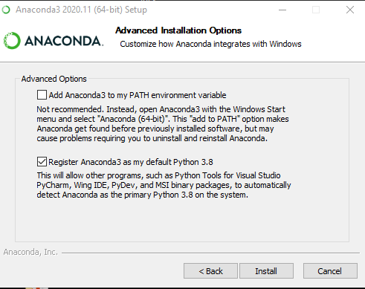

If user wants to add Anaconda to their PATH environment variable, select the top option. If user wants to register Anaconda as the default program for other related programs, select the bottom option. If the user rejects both, deselect the second option and hit “Install”. The program will then install, followed by this screen.

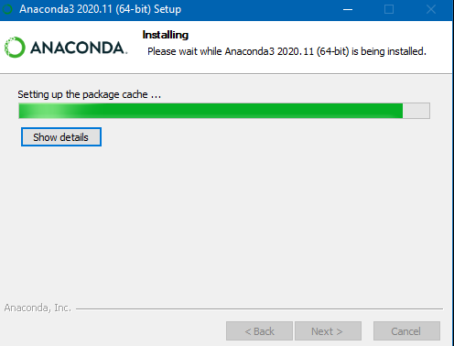

When the program has finished installing, click “Next”, and then “Next” Again. The user will be greeted by this screen.

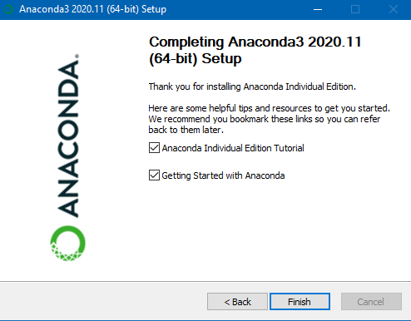

Deselect options if familiar with Anaconda, otherwise, leave options selected and hit “Finish”.

You have successfully installed Anaconda, the base program for Jupyter.

# ***Jupyter Access Instructions***

First, head to the search bar and type “Anaconda Navigator”. The program should look like the following.

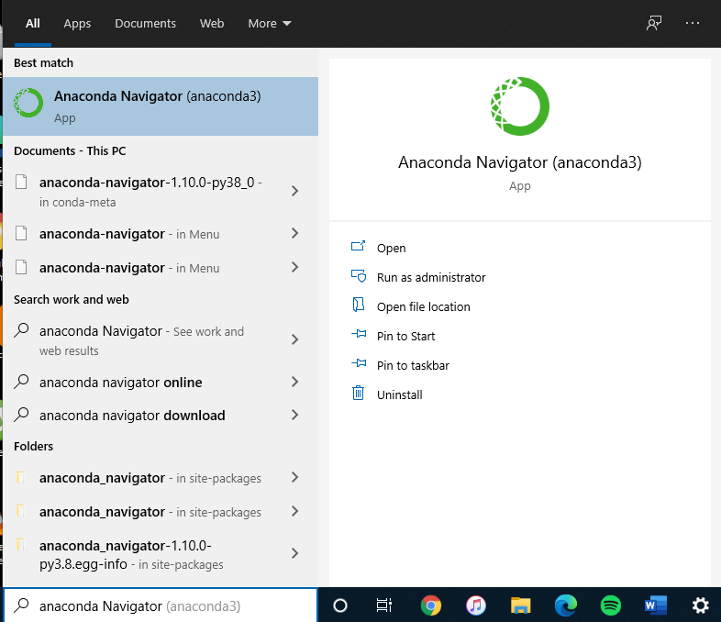

After clicking on Anaconda Navigator, and waiting some time, the following screen will appear. On the right, there is a scroll down option. Using the mouse, scroll down until you see this icon, and click “Launch”.

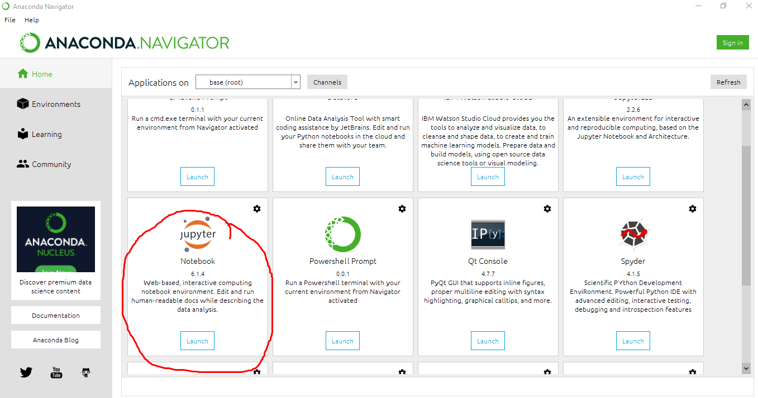

After clicking launch, the program will load as a localhost html file on your browser. Congratulations! You have successfully accessed Jupyter.

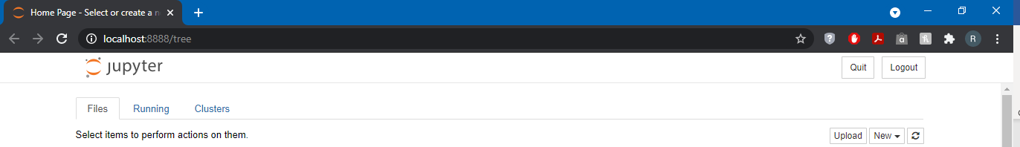

# ***Packages***

Import packages:

Import *package* as *variable*

Import features:

From *package* import *feature*

Imported packages:

* Seaborn
* Pandas
* Numpy
* Datetime
* Matplotlib.pyplot
  + imread
* Sklearn
  + Logistic regression
  + Linear regression
  + Train test split
  + RFE
  + Confusion matrix
  + Accuracy score
  + Mean Squared Error
  + R2 Score
  + Polyfit
  + MLPClassifier
  + Decision tree classifier
  + K Means
  + Preprocessing
* Scipy
  + Stats
  + Personr

# ***Dataset and Dataframe Manipulation***

## *Data Cleaning and Manipulation*

*Variable* = pd.read_csv(“*pathname of dataset*”)

Imported Data:

* Eastern Data Combined
* Western Combined Data
* Rename Consolidated Data Combined
* PACE Students - Market Data
* PACE Students – Wholesaler to Retail

Display column names:

*Variable*.columns

## *Aggregating Data*

Drop columns:

*New variable* = *old variable*.drop([‘*column name’*, ‘*column name’*, ‘*column name’*], axis = 1).dropna()

Note:

axis = 0: drop rows

axis = 1: drop columns

dropna(): drop null values

Merge like variables together:

*New variable* = *old variable*.groupby([‘*column name’*, ‘*column name’*]).sum().resetindex

Note:

sum(): sums the like variables together, this can be replaced with other actions

resetindex: resets the index to order by date, number and alphabetical order

Display first few rows of a table:

*Variable*.head()

# ***Documentation***

## *Legend*

The documentation corresponds to the MVP code written in Python. The subheadings correspond to the code and the same functions explained before are not repeated. Characteristics that can be changed to suit various purposes are depicted in *italics* (i.e. *variables*). Explanation of parameters of the code are listed under “Note:”.

## *Packages*

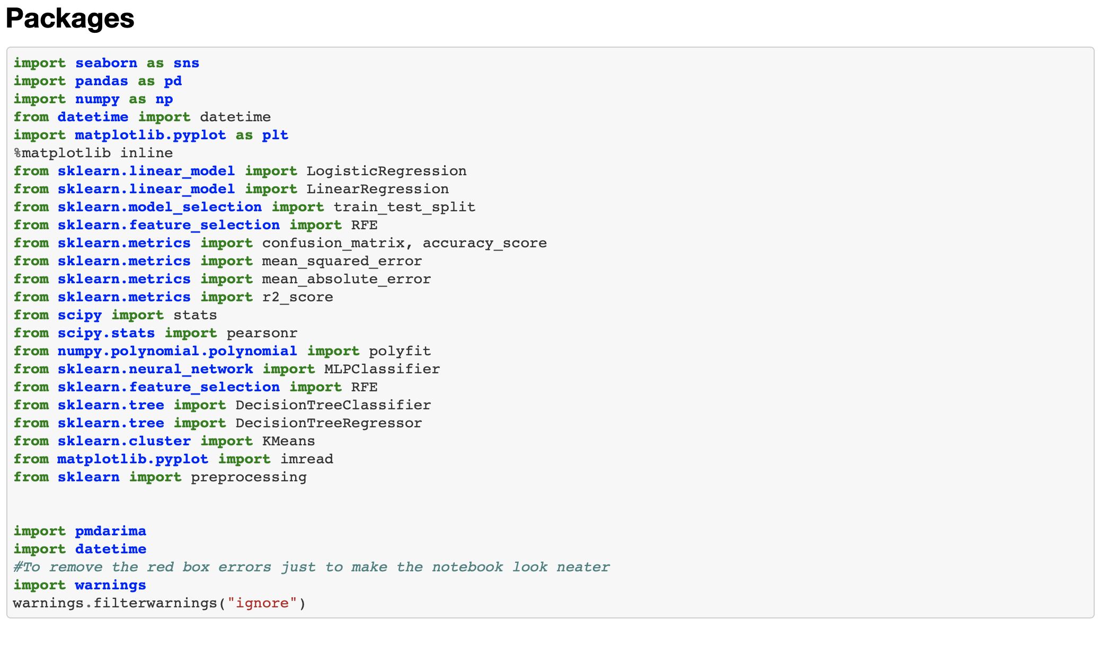

Import packages:

Import *package* as *variable*

Import module:

From *package* import *module*

Imported packages and their modules:

* Seaborn
* Pandas
* Numpy
* Datetime
* PmdARIMA
* Warnings
* Matplotlib.pyplot
  + imread
* Sklearn
  + Logistic regression
  + Linear regression
  + Train test split
  + RFE
  + Confusion matrix
  + Accuracy score
  + Mean Squared Error
  + R2 Score
  + Polyfit
  + MLPClassifier
  + Decision Tree Classifier
  + Decision Tree Regressor
  + K Means
  + Preprocessing
* Scipy
  + Stats
  + Personr

# ***Dataset and Dataframe Manipulation***

## ***Data Cleaning and Manipulation***

Import Data:

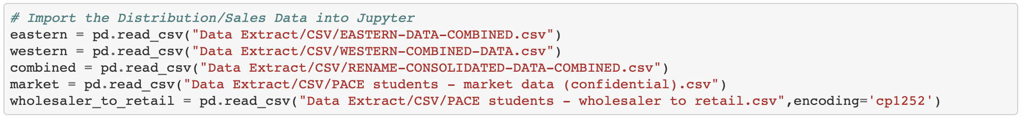

*Variable* = pd.read_csv(“*pathname of dataset*”)

Imported Data:

* Eastern Data Combined
* Western Combined Data
* Rename Consolidated Data Combined
* PACE Students - Market Data
* PACE Students – Wholesaler to Retail

Display column names:



*Variable*.columns

## ***Aggregating Data***

Drop columns:

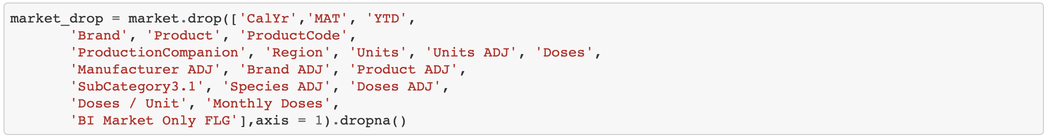

*New variable* = *old variable*.drop([‘*column name’*, ‘*column name’*, ‘*column name’*], axis = 1).dropna()

Note:

axis = 0: drop rows

axis = 1: drop columns

dropna(): drop null values

Merge like variables together:



*New variable* = *old variable*.groupby([‘*column name’*, ‘*column name’*]).sum().resetindex

Note:

sum(): sums the like variables together, this can be replaced with other actions

resetindex: resets the index to order by date, number and alphabetical order

Display first few rows of a table:



*Variable*.head()

# ***Data Visualisation / Exploration***

Plot line graphs of each parameter (BI Business Units):

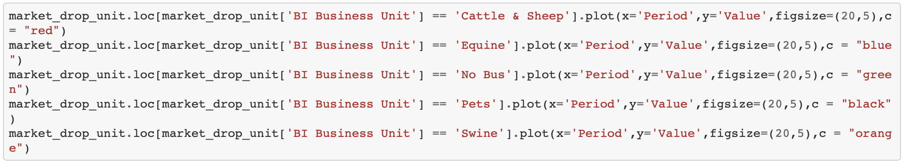

*Dataframe*.loc[*dataframe*[‘*column name’*] == *parameter*].plot(x= ‘*variable*’, y=’*variable’*, figsize = (*number, number*), c= “*colour”*)

Note:

.loc: Accesses rows or columns by labels

.plot: To plot

x= : Name of variable to be plotted on x-axis

y= : Name of variable to be plotted on y-axis

figsize= : Size of the plot

c= : Colour of the line

Plot period vs value of each parameter together (BI Business Units):

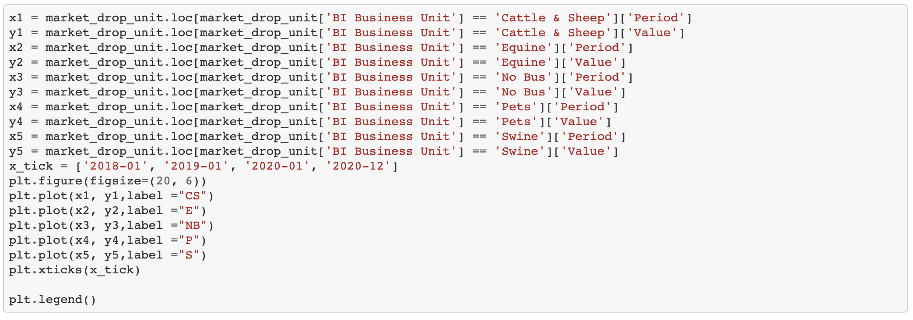

*Variable* = *dataframe*.loc[*dataframe*[‘*column name’*] == *parameter*]

*Variable*.plot(*x variable*, *y variable*, label =“*name”*)

*Variable.*xticks(“*x axis labels”*)

*Variable*.legend()

Note:

Label = : Legend label name

.xticks: x axis labels

.legend(): Include legend

Several lines can be plotted together using .plot

# ***Modelling***

## ***Creating Model Dataframe***

Find and sort unique items in an array:

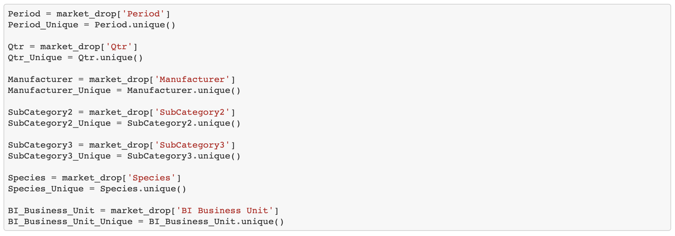

*Variable*.unique()

Transform labels into numerical labels:

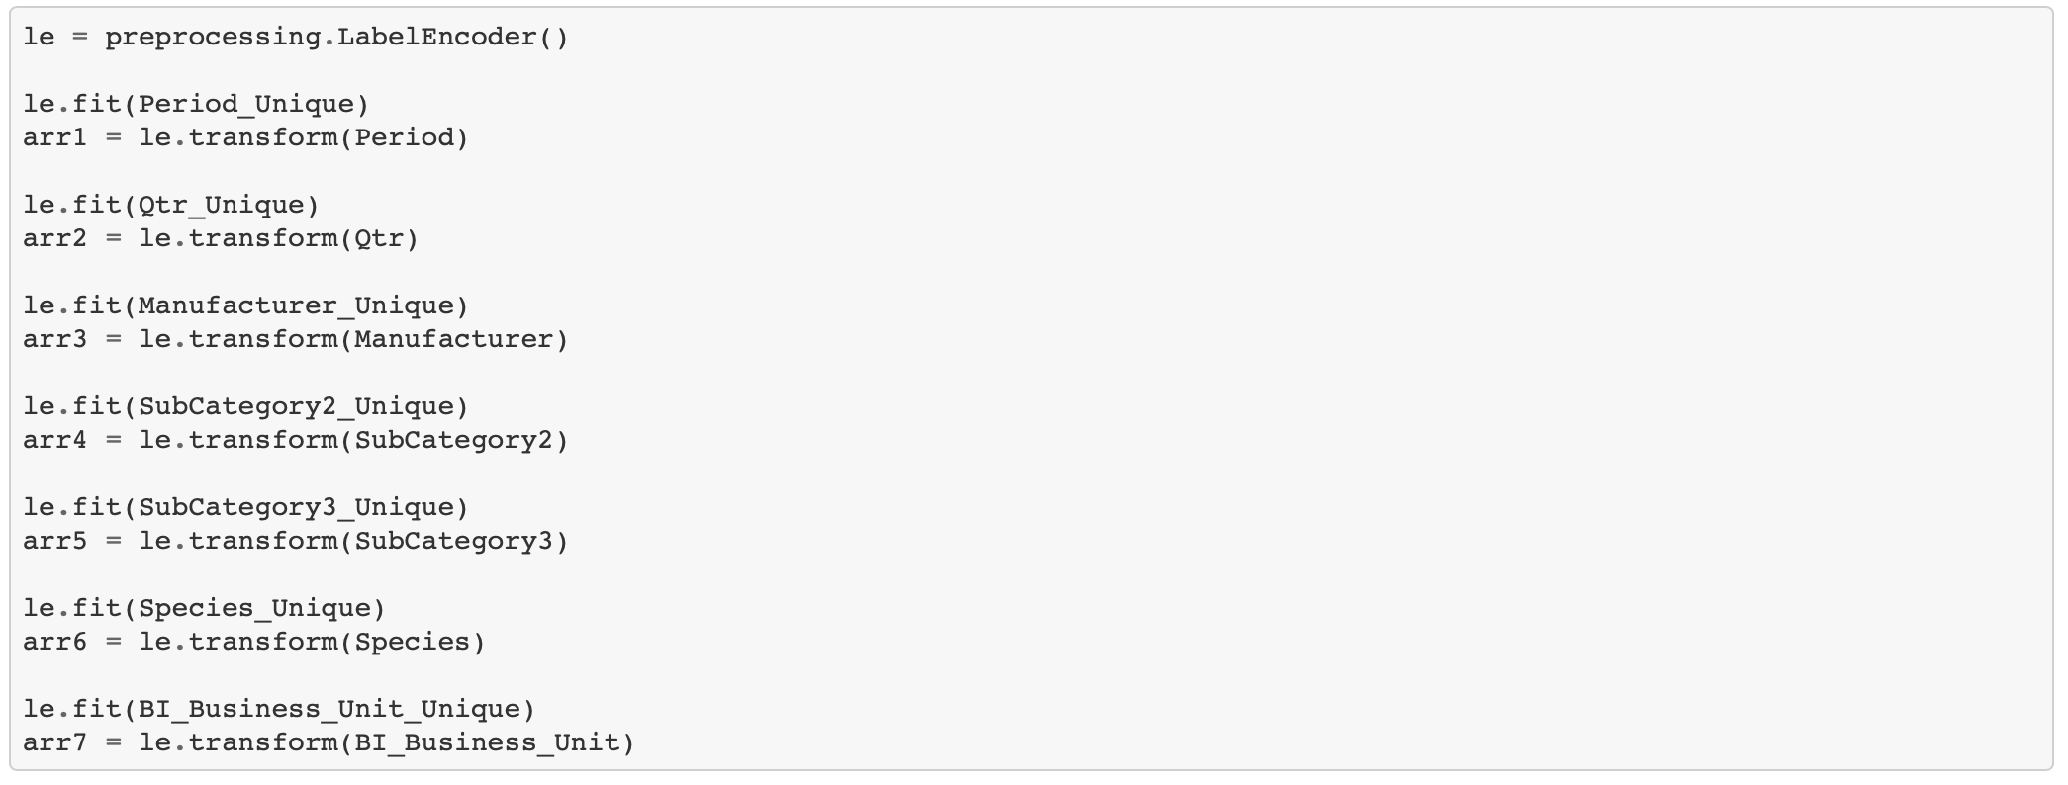

*variable* = preprocessing.LabelEncoder()

*variable*.fit(*column name*)

*variable*.transform(*column name)*

Note:

.fit: Order numerical labels

.transform: Reassign labels to the data

Create a new table:

pd.DataFrame({‘*Column Name’*: *Data*, ‘*Column Name*’: Data})

Create a scatterplot matrix:

sns.pairplot(*dataframe*)

Perform linear regression:

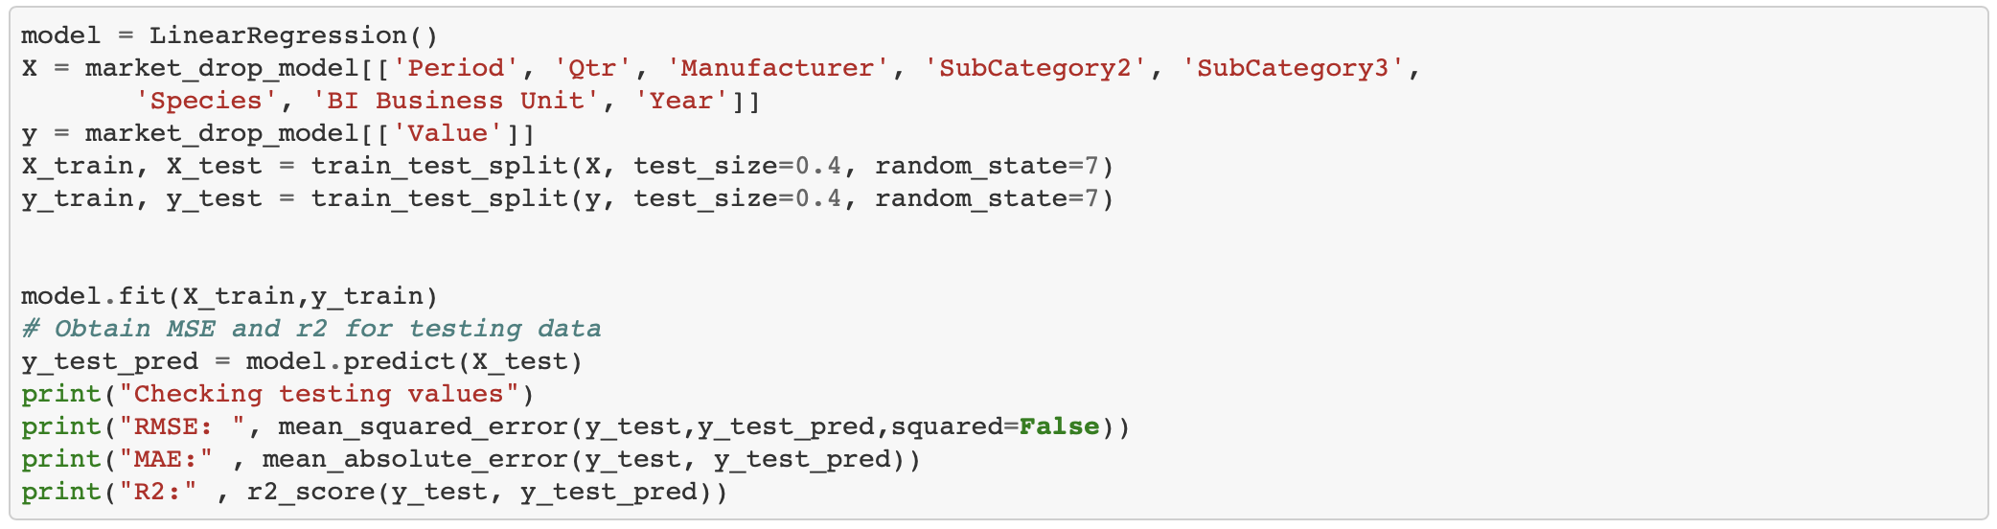

*Model* = LinearRegression()

X = *dataframe*[[‘*Column Name’, ‘Column Name’*]]

y = *dataframe*[[‘*Column Name’*]]

X_train, X_test = train_test_split(X, test_size = *number*, random_state = *number*)

y_train, y_test = train_test_split(y, test_size = *number*, random_state = *number*)

*Model*.fit(X_train, y_train)

y_test_pred = *Model*.predict(X_test)

print(mean_squared_error(y_test, y_test_pred, squared = False))

print(mean_absolute_error(y_test, y_test_pred)

print(r2_score(y_test, y_test_pred))

Note:

test_size: size of testing data in a percentage

random_state: to guarantee output is the same when ran twice

mean_squared_error: Mean squared error calculator

mean_absolute_error: Mean absolute error calculator

r2_score: R^2 score calculator

This can be performed using one or more x variables

## ***KNN***

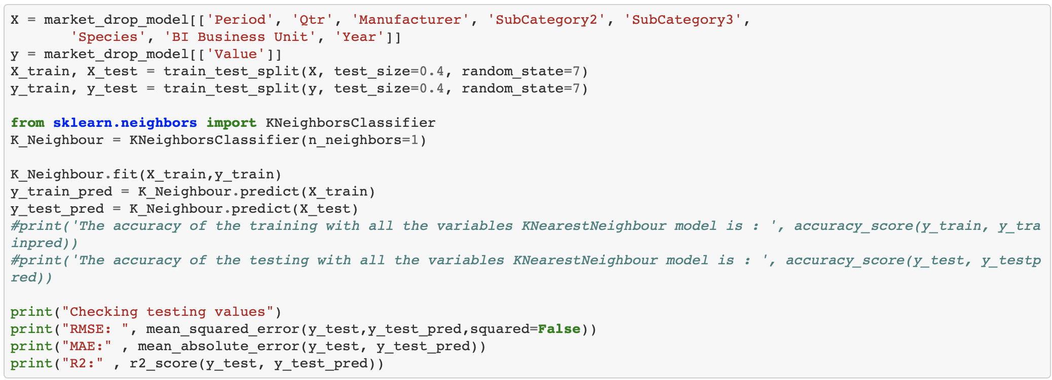

from sklearn.neighbors import KNeighborsClassifier

K_Neighbour = KNeighborsClassifier(n_neighbors=*number*)

K_Neighbour.fit(X_train,y_train)

y_train_pred = K_Neighbour.predict(X_train)

y_test_pred = K_Neighbour.predict(X_test)

print("Checking testing values")

print("RMSE: ", mean_squared_error(y_test,y_test_pred,squared=False))

print("MAE:" , mean_absolute_error(y_test, y_test_pred))

print("R2:" , r2_score(y_test, y_test_pred))

Note:

n_neighbors: Number of neighbours

## ***ARIMA***

Display first rows of a table:



*Dataframe*.info()

Import ARIMA modelling package:

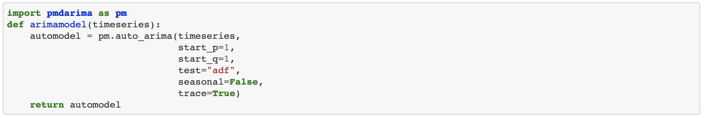

This also has to be performed through terminal using the commands as follows

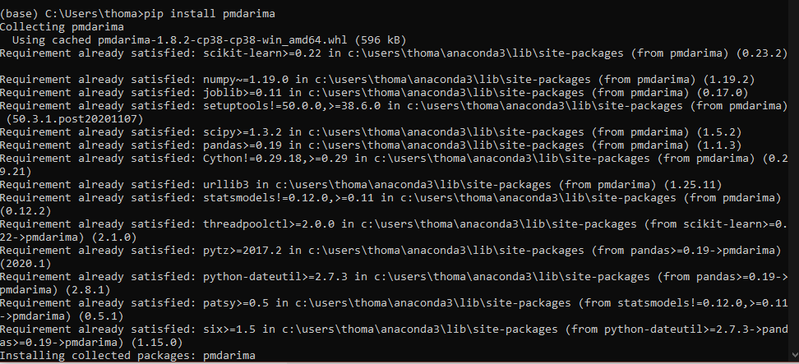

Create call function:

**def** *plotarima*(*n_periods,* *timeseries*, *automodel*):

*# Forecast*

*fc, confint* = *automodel.*predict(n_periods=n_periods, return_conf_int=**True**)

*# Weekly index*

fc_ind = pd.*date_range*(*timeseries*.index[*timeseries*.shape[0]-1], periods=n_periods, freq= "*W*")

*# Forecast series*

fc_series = pd.Series(fc, index=fc_ind)

*# Upper and lower confidence bounds*

lower_series = pd.Series(confint[:, 0], index=fc_ind)

upper_series = pd.Series(confint[:, 1], index=fc_ind)

*# Create plot*

plt.figure(figsize=(10, 6))

plt.plot(timeseries)

plt.plot(fc_series, color="*colour*")

plt.xlabel("*date*")

plt.ylabel(timeseries.name)

plt.fill_between(lower_series.index,

lower_series,

upper_series,

color="*colour*",

alpha=*number*)

plt.legend(("*column names*"), loc="*location*")

plt.show()

Note:

Freq: Common types are M, W or BM. M is month, W is week and BM is business month end

Confint: Confidence interval

[:, 0]: First row to last row of column 0

Loc: Location of the legend

Alpha: Confidence level

Call the ARIMA function:



plotarima(*number of time periods*

## ***DTR***

Decision Tree Regressor:

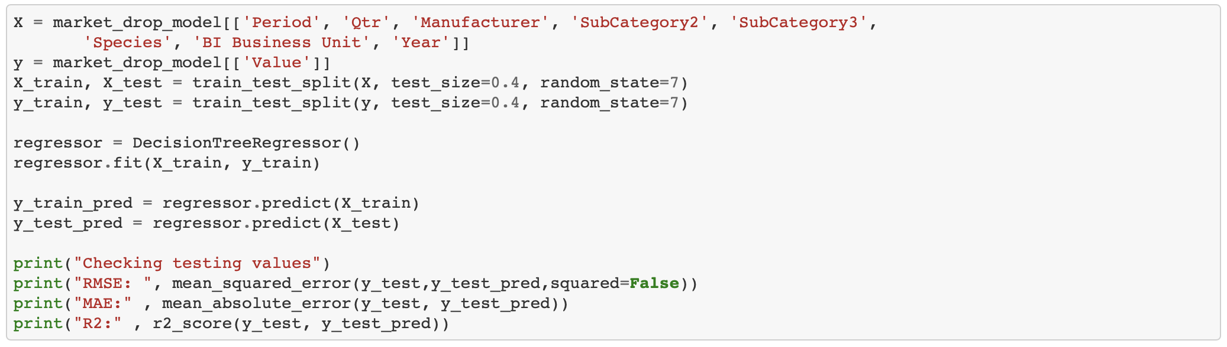

X = *dataframe*[[‘*Column Name’, ‘Column Name’*]]

y = *dataframe*[[‘*Column Name’*]]

X_train, X_test = train_test_split(X, test_size = *number*, random_state = *number*)

y_train, y_test = train_test_split(y, test_size = *number*, random_state = *number*)

*Model* = DecisionTreeRegressor()

*Model*.fit(X_train, y_train)

y_train_pred = *Model*.predict(X_train)

y_test_pred = *Model*.predict(X_test)

print(mean_squared_error(y_test, y_test_pred, squared = False))

print(mean_absolute_error(y_test, y_test_pred)

print(r2_score(y_test, y_test_pred))

## ***Logistic Regression***

Split into test and train as depicted above and view the shape:



Print(*variable*.shape)

Perform recursive feature elimination:

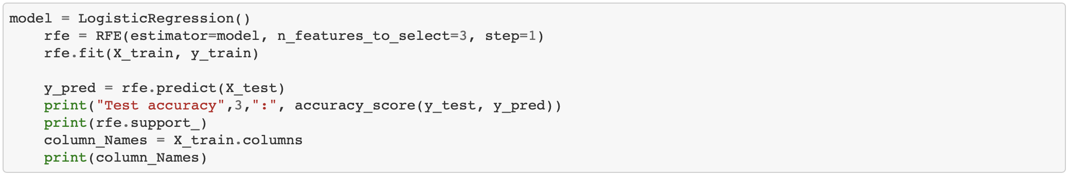

*rfe* = RFE(estimator = LogisticRegression(), n_features_to_select = *number*, step = *number)*

*Variable*(X_train, y_train)

Y_pred = *rfe*.predict(X_test)

print("Test accuracy",*number*,":", accuracy_score(y_test, y_pred))

print(*rfe*.support_)

*column_Names* = X_train.columns

print(*column_Names*)

Test the logistic regression model with different number of features:

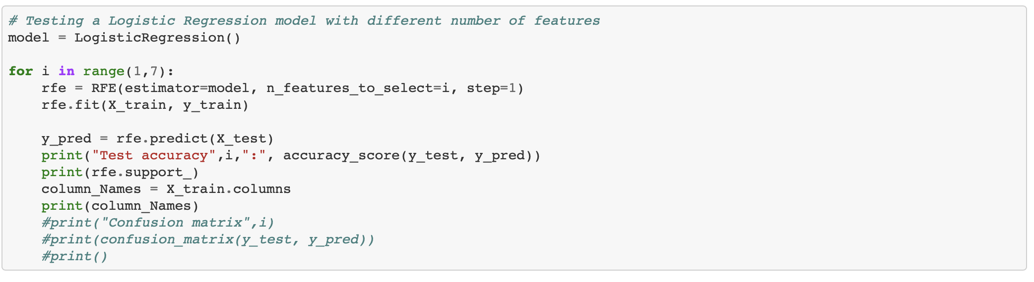

model = LogisticRegression()

**for** i **in** range(*number*,*number*):

*rfe* = RFE(estimator=model, n_features_to_select=i, step=1)

*rfe*.fit(X_train, y_train)

y_pred = *rfe*.predict(X_test)

print("Test accuracy",i,":", accuracy_score(y_test, y_pred))

print(*rfe*.support_)

*column_Names* = X_train.columns

print(*column_Names*)

Note:

The same code as above but a for loop is created to test the model.

# ***Prediction***

## ***Choosing Parameters***

In the Jupyter Notebook, the final section is called prediction and we are using this section to retrieve an expected/predicted output for our model.

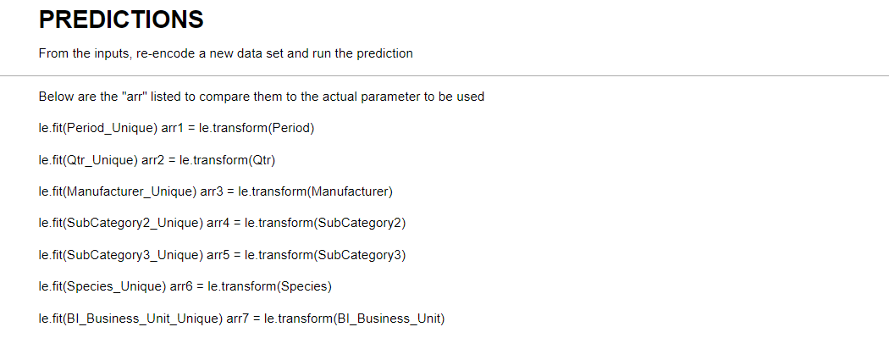

Based on the dataframes above, we will decide our encoding for the data. Additionally, this will also allow us to select a parameter we want to test. 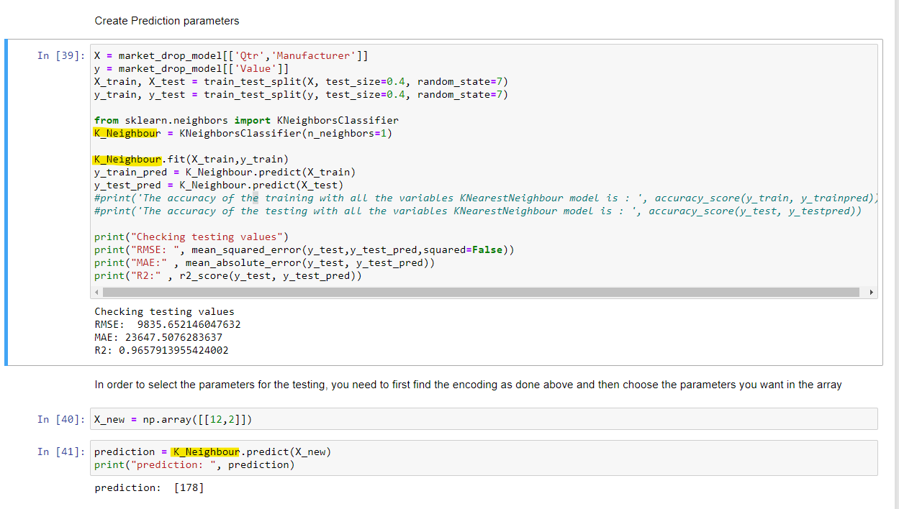

From the image above, we can see that the model used here is the KNN model and we have created the X_new as our prediction table.

After inputting the value that is used in the encoding, just run the section of code and this will give you the prediction result below.